**Home Assignment 1: Research and Design (24 hours)**

**Task 1: Game engines**

* **GoldSrc** is a 3D game engine which makes use of the C, C++, Pascal and Assembly programming languages. Some games which were programmed using this game engine are Half-Life, Team Fortress Classic.
* **Build engine** is a 2.5D game engine which makes use of the C programming language. Duke Nukem 3D, Shadow Warrior and Redneck Rampage are a few examples of games programmed by this game engine.
* **Monogame / XNA** is both a 2D and 3D engine. It makes use of the C# programming language. Some examples of games designed by this engine are Terraria, Bastion, TowerFall and Skulls of the Shogun.
* **Source 2** is a 3D game engine which makes use of the C++ and Lua programming languages. Examples of games made by this engine are Dota 2, Half-Life: Alyx, Artifact and Dota Underlords.
* **Creation Engine** is a 3D game engine which makes use of C++ and Papyrus programming languages. Some examples of games made with this engine are The Elder Scrolls V: Skyrim, Fallout 4 and Fallout 76.

**Task 2: File types for media assets**

**Image Formats**

1. **JPG:** which stands for Joint Photographic Experts Group, is a digital image format which is made up of compressed image data. JPG images are very compact as they have a compression ratio of 10:1. It is also the most popularised image format in photo and image sharing on the internet as well as between mobile and PC users.
2. **PNG:** stands for Portable Network Graphic. It is the ideal file format for digital art such as logos, icons, etc. and uses 24-bit colour as a foundation. PNG file format also supports image interlacing and develops faster than in an interlaced GIF format.
3. **GIF:** stands for Graphics Interchange Format. It is a bitmap image format which supports 8 bits per pixel for each image and is also widely supported and portable between the majority of applications and operating systems. This format supports animations however unlike video, it does not support audio.

**Audio Formats**

1. **MP3:** which is also known as an MPEG-1 Audio Layer 3, consists of MP3 frames where each frame consists of a header and data block. These data blocks of file contain information about the audio in terms of frequencies and amplitudes. A number of media players support playing MP3 files such as Microsoft Windows Media Player, VLC player and Apple iTunes.
2. **WAV:** stands for Waveform Audio File Format. It is an audio file format standard developed by IBM and Microsoft. This specific format uses containers to store audio data, sample rate, bit rate and track numbers. It is also an uncompressed lossless audio format and can take up quite a bit of space because of this.

**Task 3: Compression in multimedia**

1. Compression is very important in images. With compression, the file size can be reduced to a point where it allows more images to be stored in a given amount of storage/memory space. It also reduces the time required for images to be transferred, sent, downloaded or received over the internet. Another prime advantage of compression is the huge reduction in communication bandwidth. However despite these advantages, one should note that the image quality is dependent on whether the compression is lossy or lossless compression. If the latter is the case, one must be careful to identify the file format needed in order to compress the images without trading pristine quality for a smaller file size
2. Compression in audio explained using diagrams and self-made compression.
   1. First a raw audio sample was recorded.

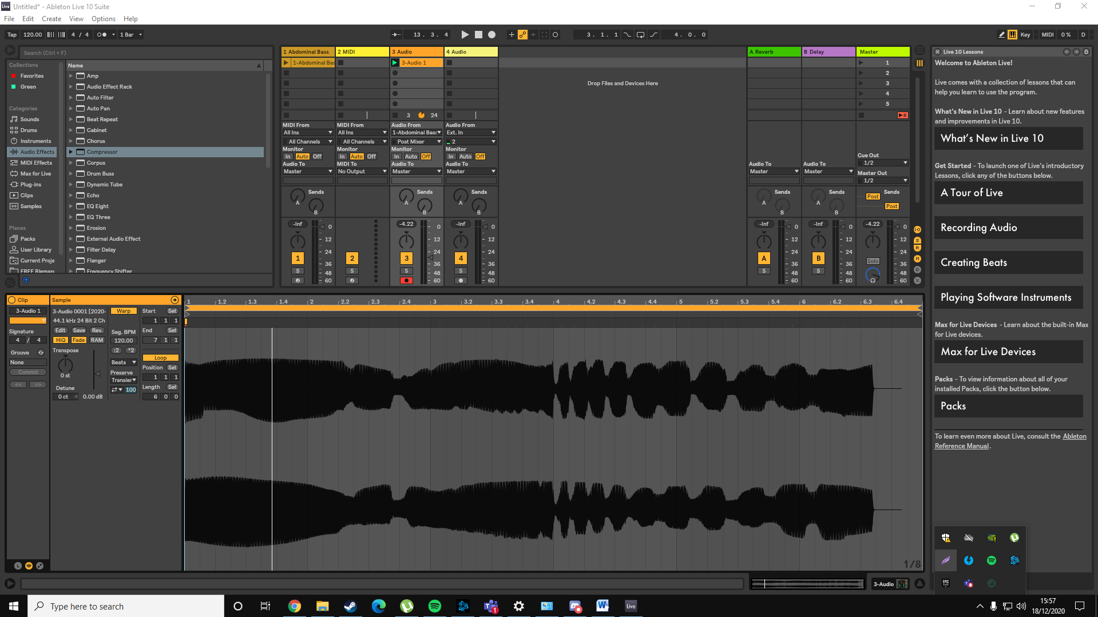

* 1. Then a compressor was added to the midi track

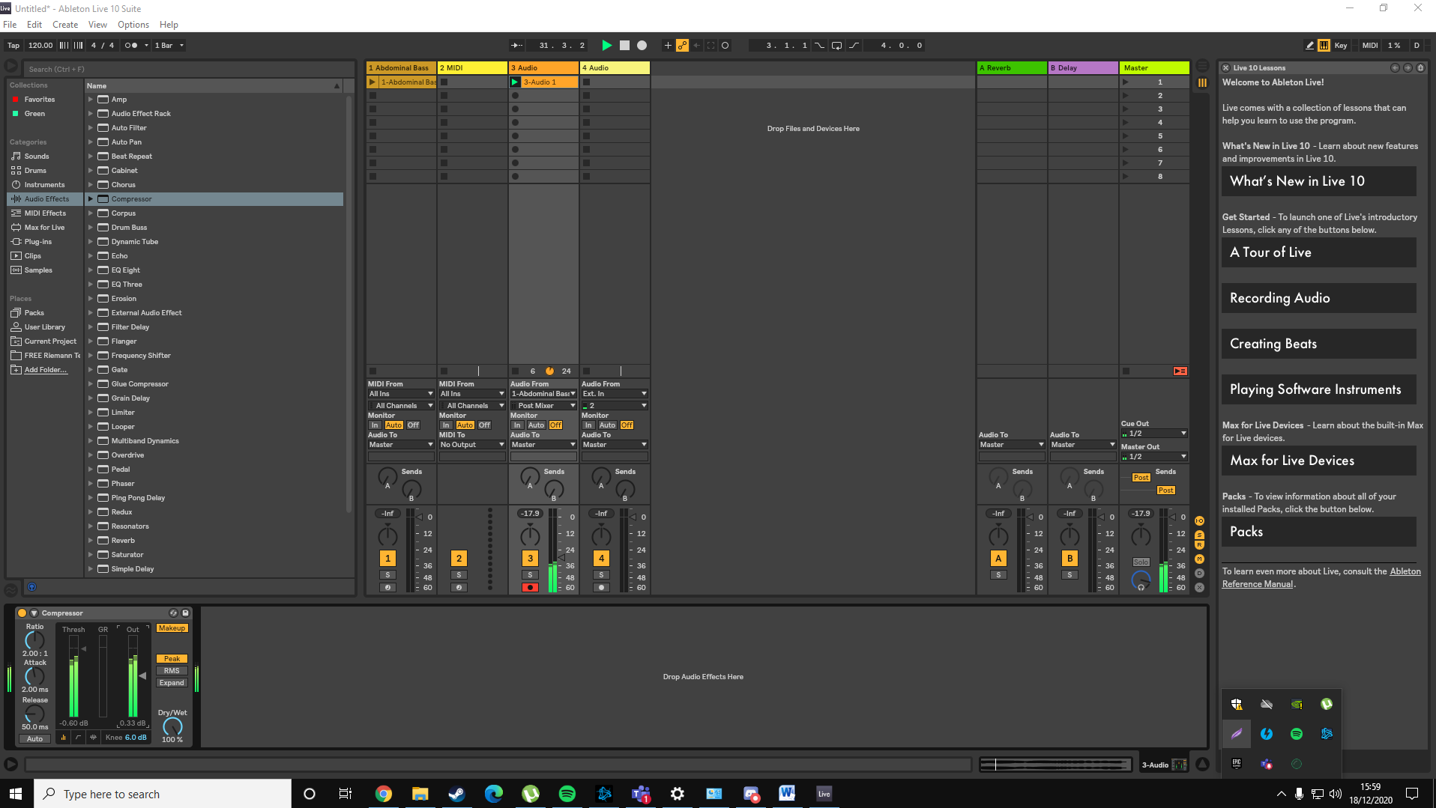

1. The threshold of the compressor was decreased and the output increased which results in the audio sample being compressed while retaining the same level of sound and even better audio quality.

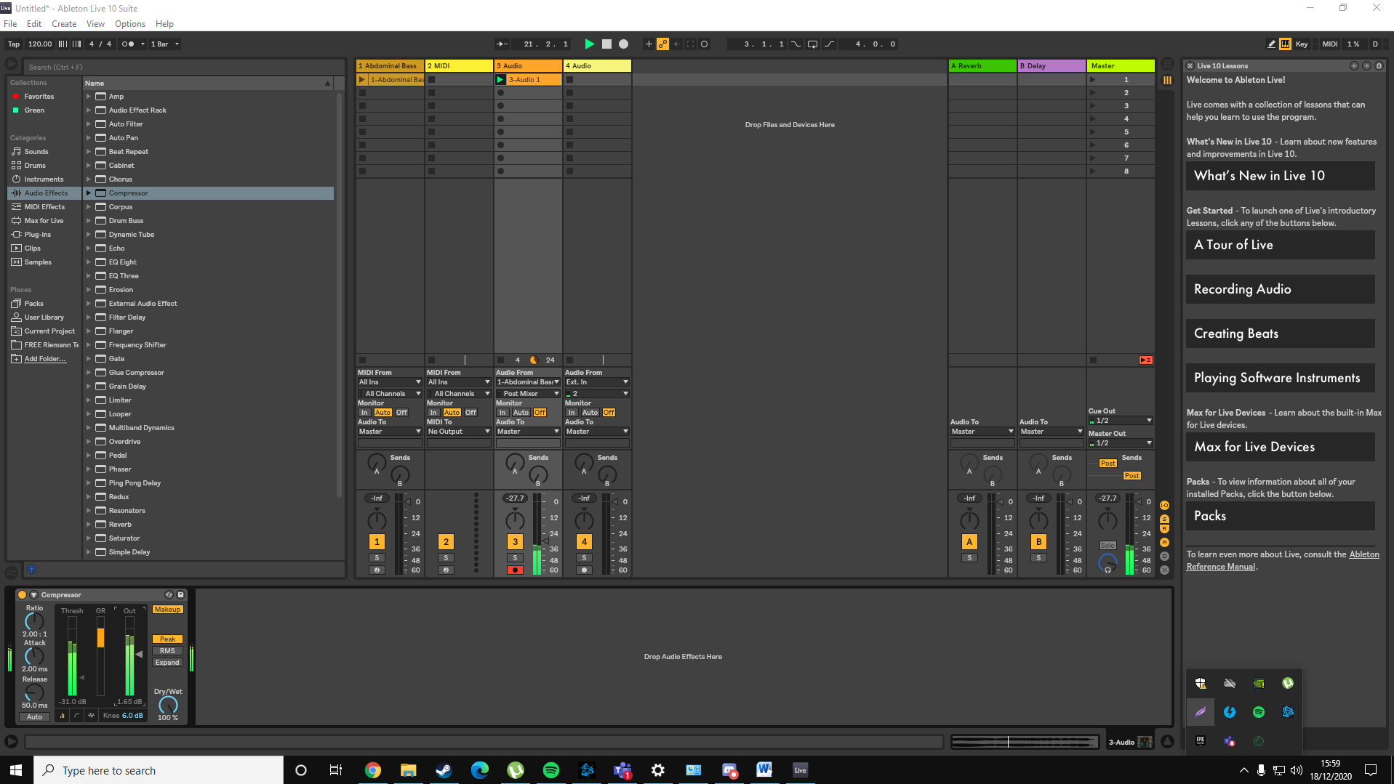

1. Here we can observe that the size of the wave of the audio sample has decreased drastically meaning that we have successfully compressed the audio sample.

